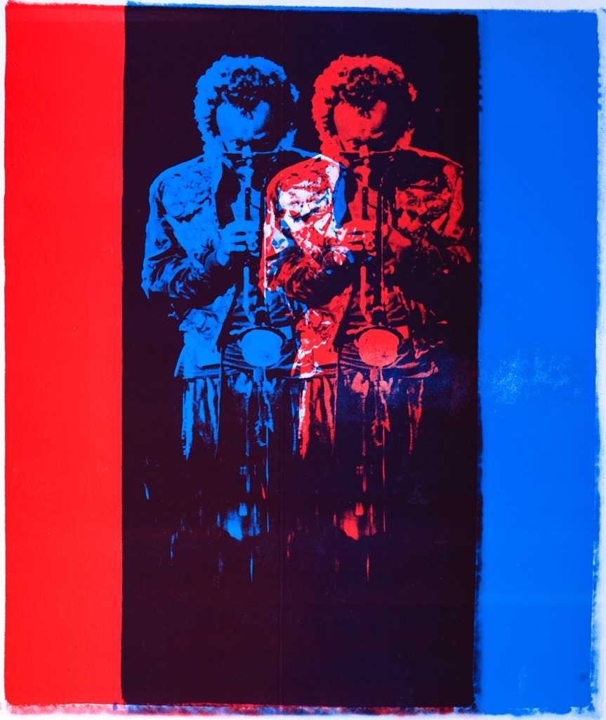

PETE WILLIAMS PHOTOGRAPHY

L A R G E W O R K S

PRINT CATALOGUE 2023

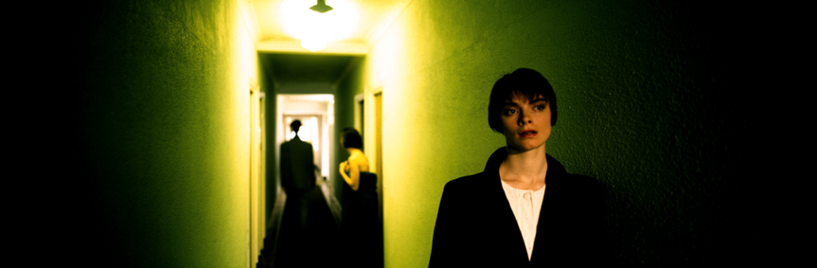

Liz Eynham
Ducane Court, Balham, London 1988
Dye Transfer print from Linhof 6x17cm panramic transparency
185 x 65cm (73x25.5in.)
Framed in oak section and teak beading

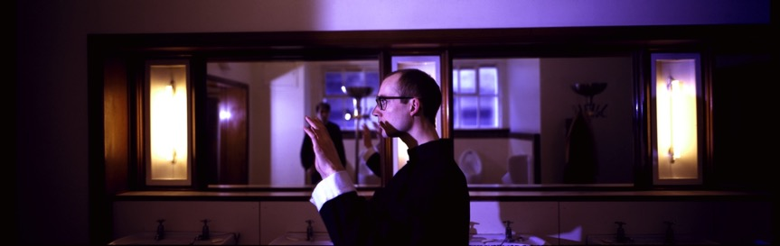

Richard Napper
Royal Institute of British Architecture, Portland Place, London 1987
Dye Transfer print from Linhof 6x17cm panoramic transparency
185 x 65cm (73x25.5in)
Framed in oak section and teak beading

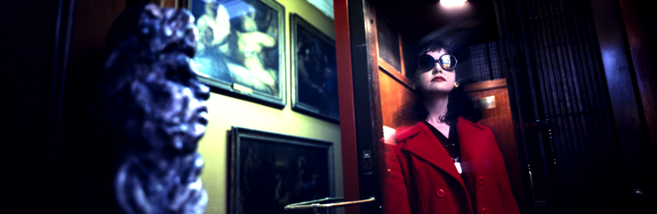

Jaqui Urry
Royal Academy, Piccadilly, London 1988
Dye transfer print from Linhof 6x17cm panoramic transparency
185 x65cm (73x25.5in)
Framed in black walnut section and teak beading

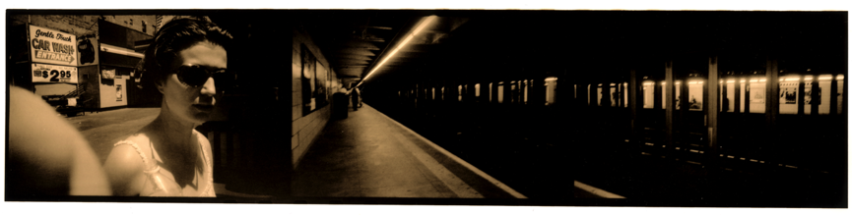
Christie West
Subway, New York 1997
Selenium toned, silver gelatin print from three 35mm negatives
183 x 46cm (72x18in)
Framed in black walnut section and teak beading

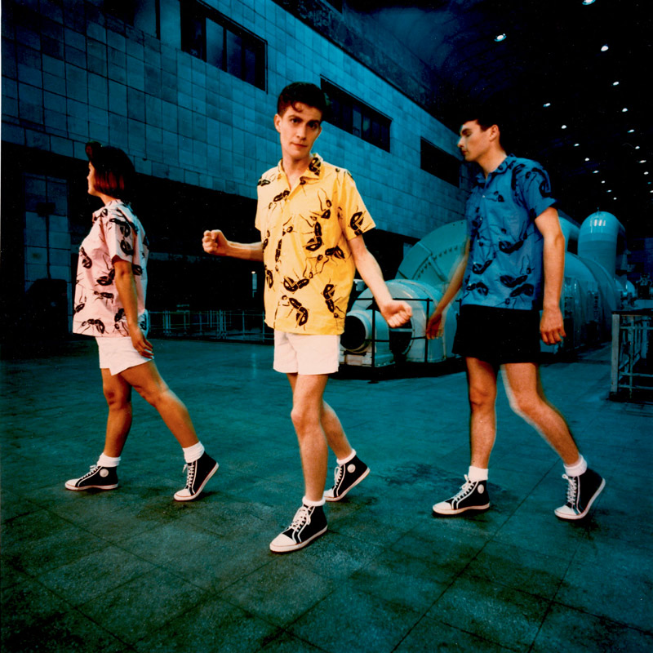

Marianne, Ben and Pete
Battersea Power station, London 1984
Dye Transfer print
76 x 76cm (30x30in)
Framed in black walnut section and teak beading

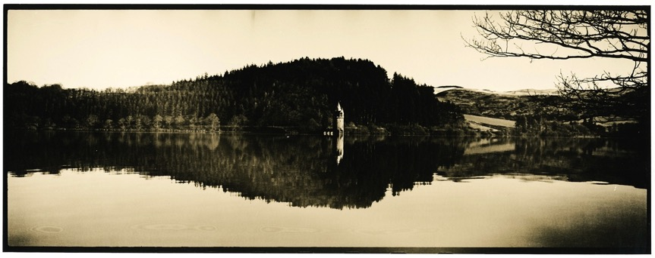

Lake Vyrnwy
North Wales, UK 1999
Selenium toned, silver gelatin print from 35mm panoramic negative
152 x 63.5cm (60x25in)
Unframed print

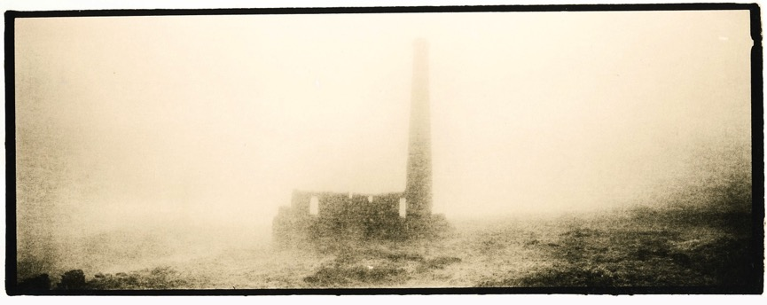

Levant Tin Mine
St Just, Cornwall, England 2001
Selenium toned, silver gelatinprint from 35mm panoramic negative
152 x 63.5cm (60x25in)
Unframed print

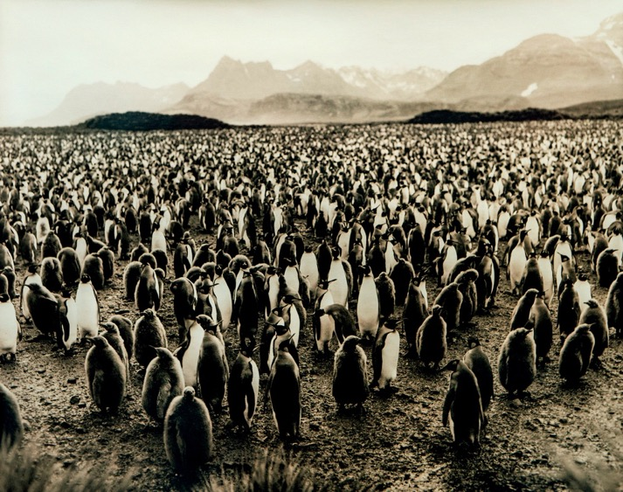

Penguin Colony 1
South Georgia, Antarctica 2017
Selenium toned, silver gelatin print
101.5 x 76cm (40x30in)
Framed in black walnut section with museum board window mount.

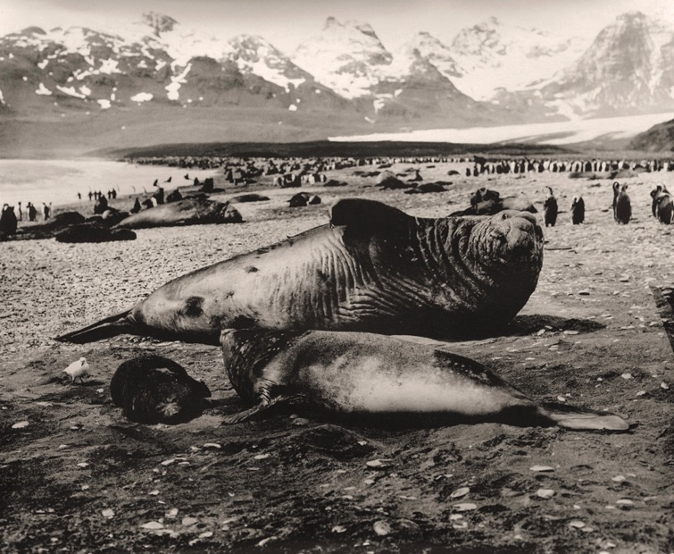

Elephant Seals
South Georgia, Antarctica 2017
Selenium toned, silver gelatin print
101.5 x 76cm (40x30in)
Framed in black walnut section with museum board window mount

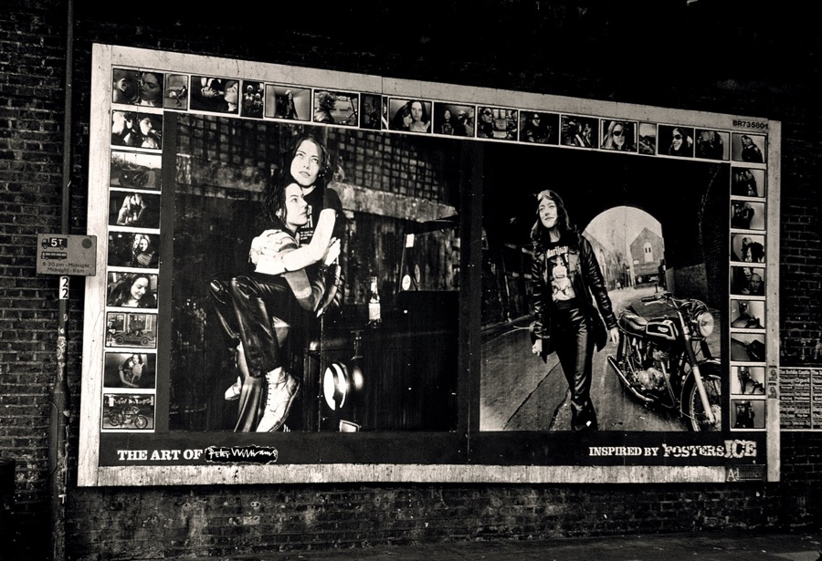

Rachel and Teresa
Camden Town, London 1995
Silver gelatin prints mounted on marine ply
609.5 x 305cm (240x120in) 20x10 foot

Street Art project commissioned by Fosters Lager
Ten works, nine Graffiti, one photographic.

Erected in the summer of 1995 commissioning the most significant and influential
Graffiti Artists from America and Europe.

Art directed by Grafix legend Swifty, he asked me to produce a photographic work in keeping with the Fosters brief, which was anything goes.

All works were sold off at auction in 1998 to unknown buyers.

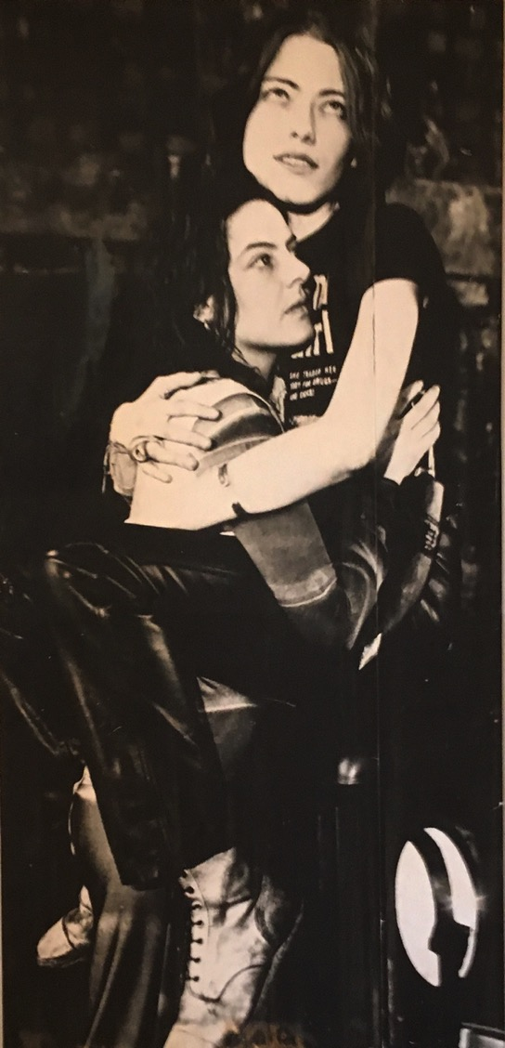

Rachel and Teresa
Borough Market, London Bridge, London 1995
Silver gelatin print
244 x 122cm (96x48in)
Framed in oak and teak

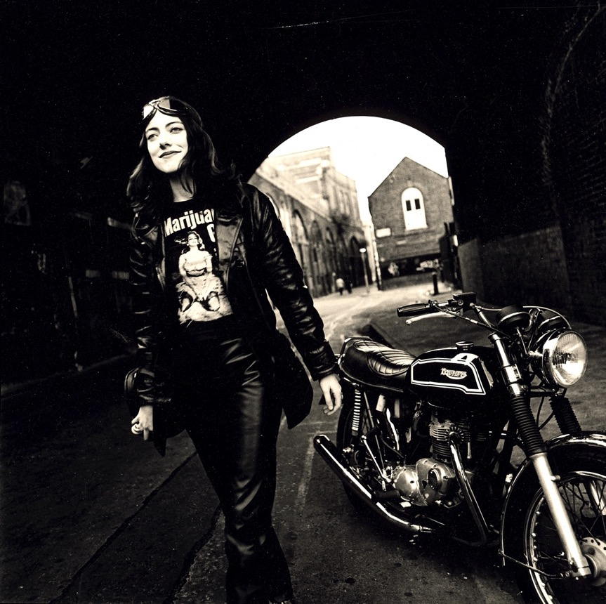

Rachel
Borough Market, London Bridge, London 1995
Silver gelatin print
76 x 76cm (30x30in)
Framed in oak section and teak beading

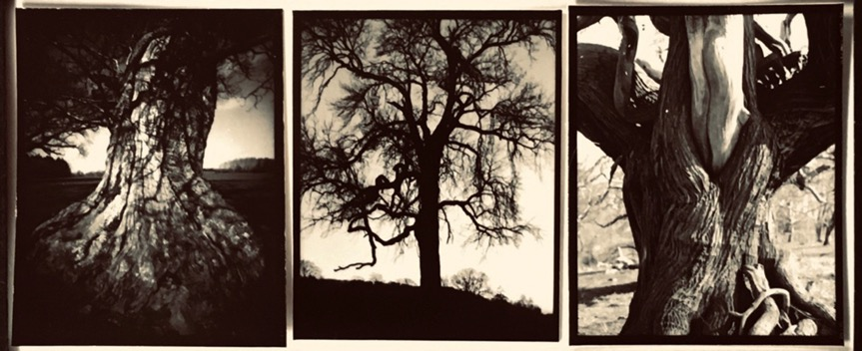

Two Oaks and a Chestnut Triptych
Herefordshire, England 2021
Three selenium toned, silver gelatin, lith prints
152 x 61cm (60x24in)
Framed in oak section and teak beading

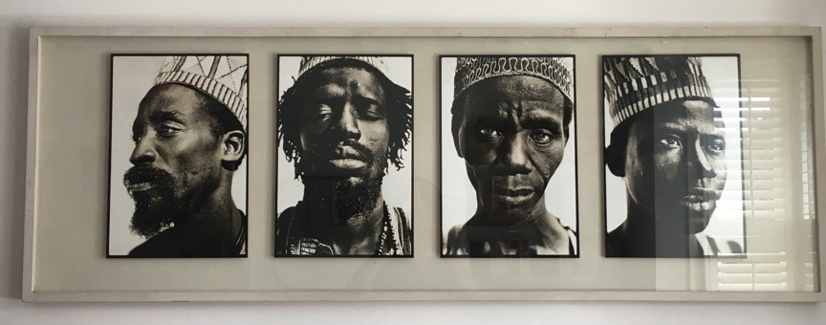

Pan Africa 2
Real World Records, Box Wiltshire, England 1994
Four selenium toned, silver gelatin, lith prints, dry mounted on museum board
185 x 65cm (73x25.5in)
Painted oak section box frame with floating prints

